**Project Work QA Testing**

**Project URL:** [**https://test-nf.com/english.html**](https://test-nf.com/english.html)

**Task 1: User Story Analysis and Test Scenario Development**

**User Story**

**User Story 0001:** Add About us link option in footer of the application

**Description:** The scope of this US is to provide ‘About us’ link so that users can click on the link and get all the details about the organization vision and mission.

**Acceptance Criteria:**

* + 1. Users should be able to click on the ‘About us’ link
    2. ‘About us’ link should be displayed in footer part (as per the mock-up)
    3. When user click on the ‘About us’ link system will navigate to new page which display the Organization Vision and Mission.
    4. ‘About us’ link should be available for all the tabs (Home, Cricket, Football, Basketball and Ciber Sports)

**Mock-up:**

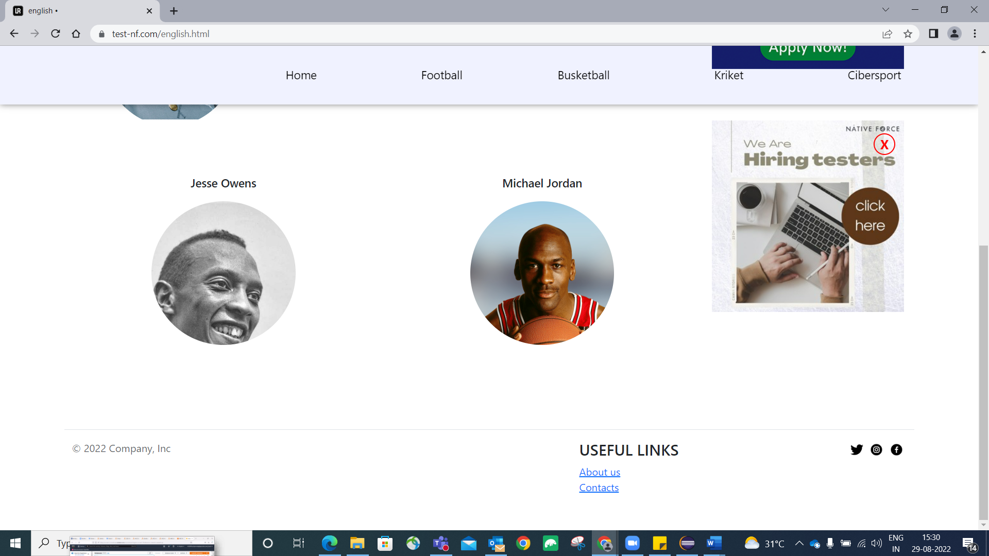

Table Format:

|  |  |  |  |
| --- | --- | --- | --- |
| Sl No | Test Case | Expected Result | Test Data |

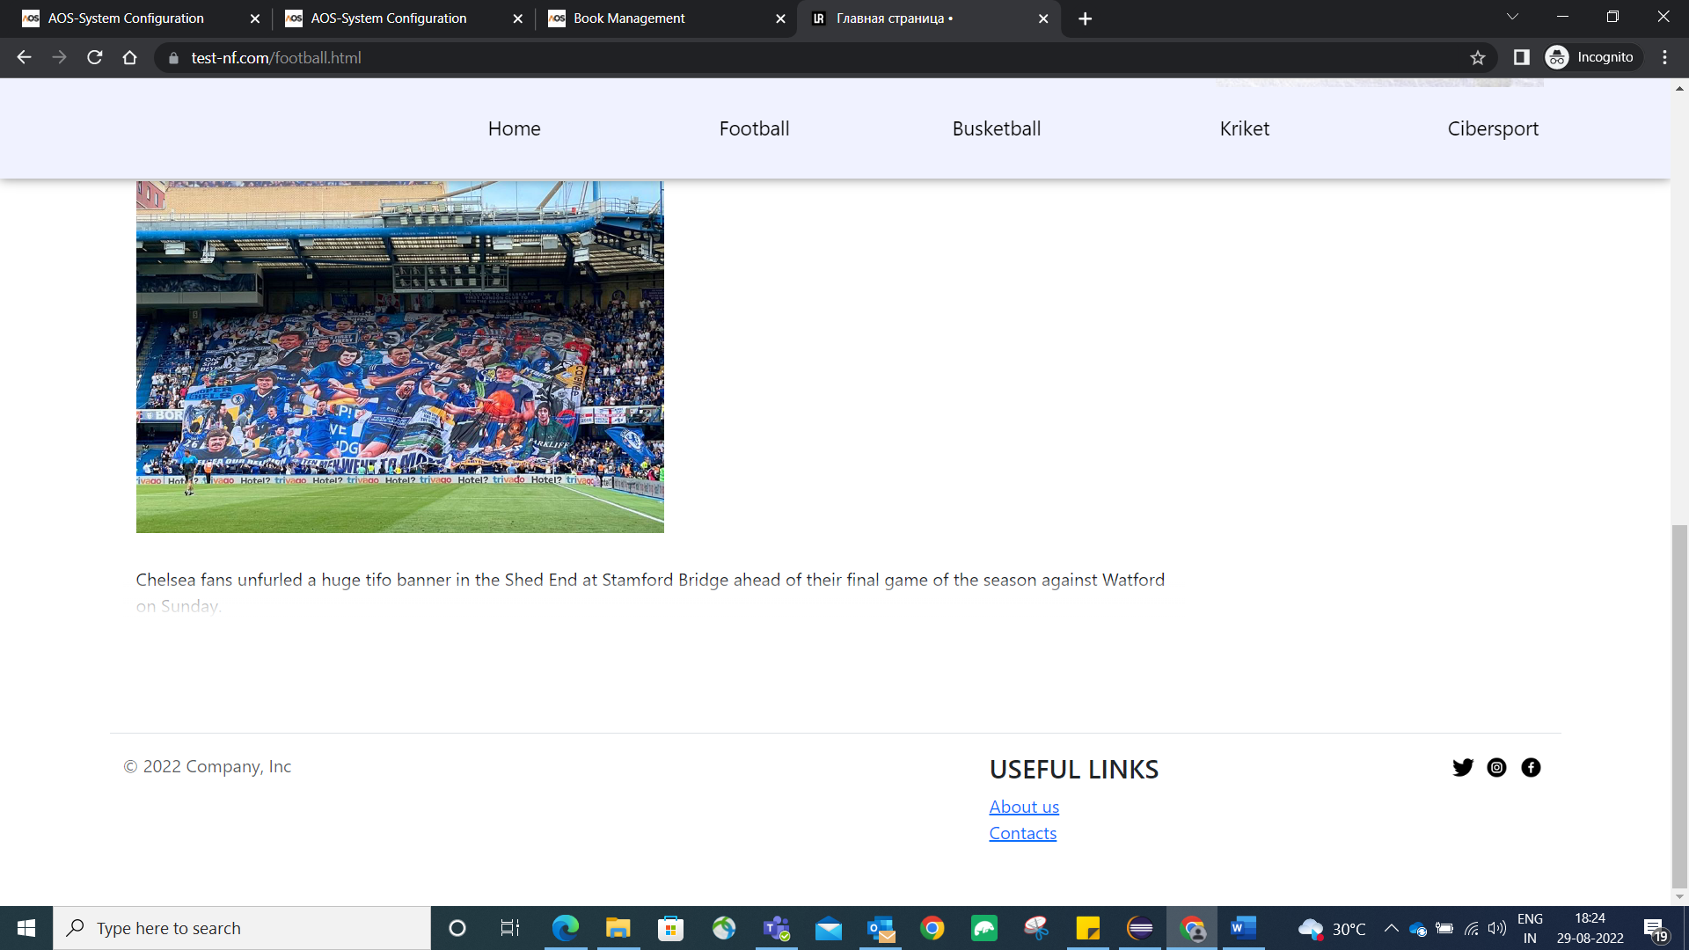

**Task 2: Prepare Automation Test Script and also perform the test execution**

**Automation Testing Scenario:**

1. Launch the application**:** [**https://test-nf.com/english.html**](https://test-nf.com/english.html)
2. Verify the availability of each tab(Home, Cricket, Football, Basketball and Ciber Sports)
3. Verify URL of each tab contains the tab name.
4. Store all the current URL in excel sheet.

**Note:** Implement Page Object model, Assertion for Validation, Excel Sheet Integration for passing System properties and application URL.

**Task 3: Bug finding and bug reporting**

1. Find out all the possible bug in the home page of application and provide below details:

* Bug Title
* Bug Priority
* Bug Severity